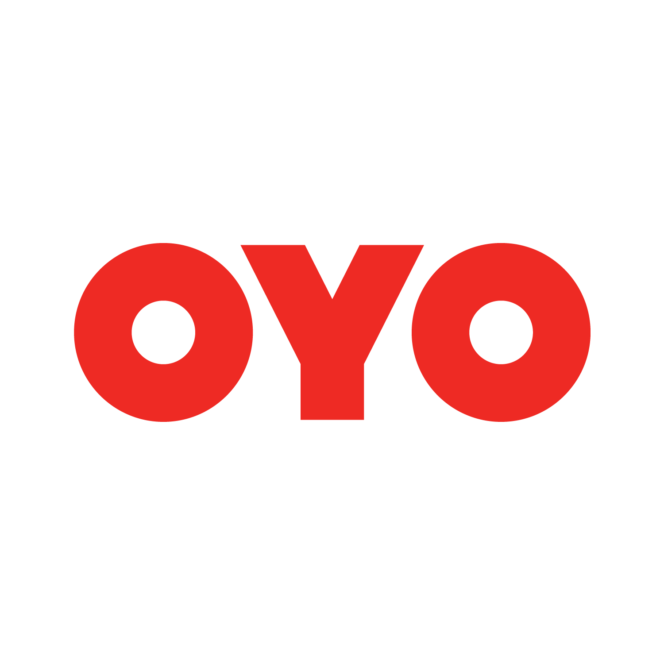

Hotel Name | Single Occupancy | Double  Occupancy | Triple Occupancy | Hotel Category | Rooms Availability
Edition O 30029 Hotel Blue Moon | 1800 | 2200 | 2500 | Premium | 20
Edition O 30067 Friends colony East | 1800 | 2200 | 2500 | Premium | 57
OYO 9553 Hotel Kings Plaza | 1200 | 1400 | 1700 | Budget | 15
OYO 23681 hira palace | 1200 | 1400 | 1700 | Budget | 30

Contact person - Parmindra Negi
Mobile no - 7976145564
Email id- parmindra.negi@oyorooms.com

